Basic Automation

Tasks:

Test Case 1: Login Validation
- Steps:
  - Open login page
  - Enter valid credentials
  - Click login
- Expected:
  - User should login successfully
- Result:
  - Passed

Selenium Code:
from selenium import webdriver
from selenium.webdriver.common.by import By
import time
driver = webdriver.Chrome()
driver.get("https://the-internet.herokuapp.com/login")
time.sleep(2)

# Enter username
driver.find_element(By.ID, "username").send_keys("tomsmith")

# Enter password
driver.find_element(By.ID, "password").send_keys("SuperSecretPassword!")

driver.find_element(By.CSS_SELECTOR, "button[type='submit']").click()
time.sleep(2)
if "secure" in driver.current_url:
print("✅ Login Test Passed")
else:
print("❌ Login Test Failed")
driver.quit()

Test Case 2: Dashboard Test
- Steps:
  - Login
  - Check dashboard message
- Expected:
  - Dashboard message visible
- Result:
  - Passed
Selenium Code :
# Check dashboard message
message = driver.find_element(By.ID, "flash").text
if "You logged into a secure area!" in message:
print("Dashboard Test Passed")
else:
print(" Dashboard Test Failed")
driver.find_element(By.ID, "username").send_keys("wrong")
driver.find_element(By.ID, "password").send_keys("wrong")
driver.find_element(By.CSS_SELECTOR, "button[type='submit']").click()

error = driver.find_element(By.ID, "flash").text
if "Your username is invalid!" in error:
print(" Negative Test Passed")
else:
print("Negative Test Failed")
ScreenShots:
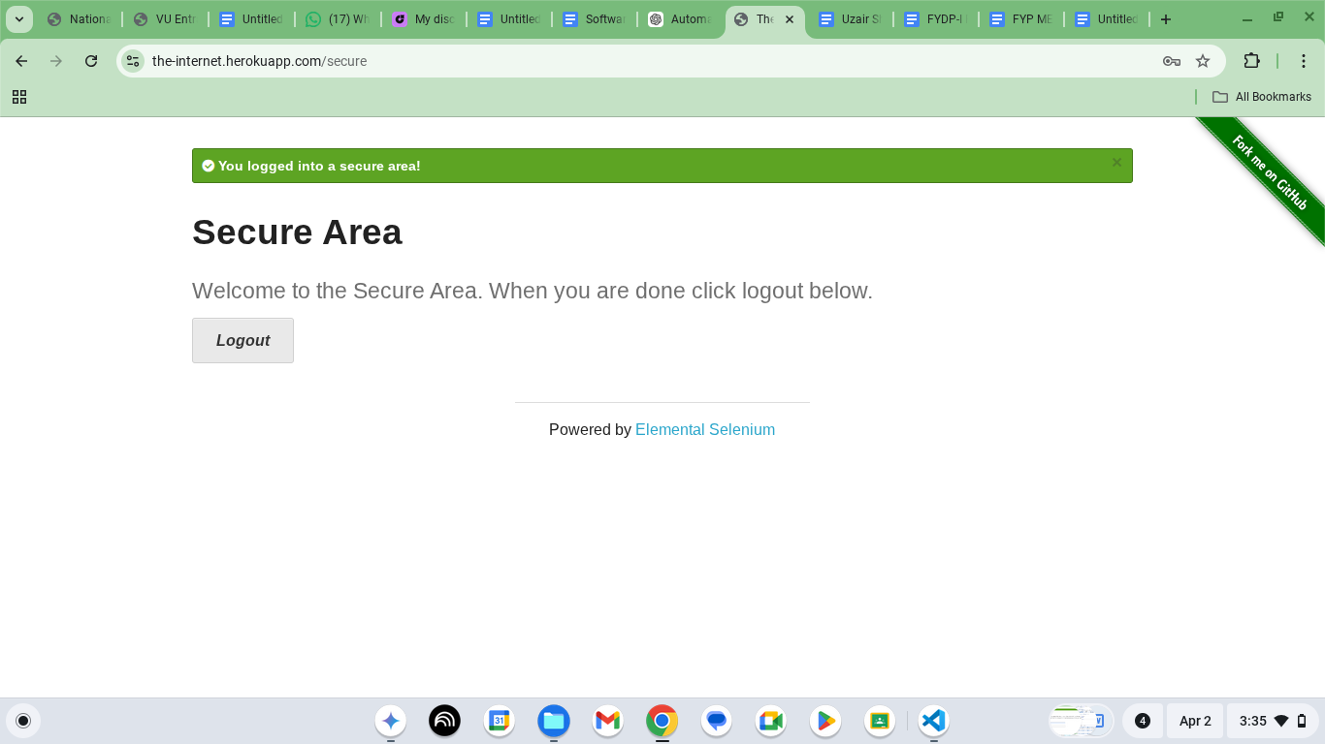
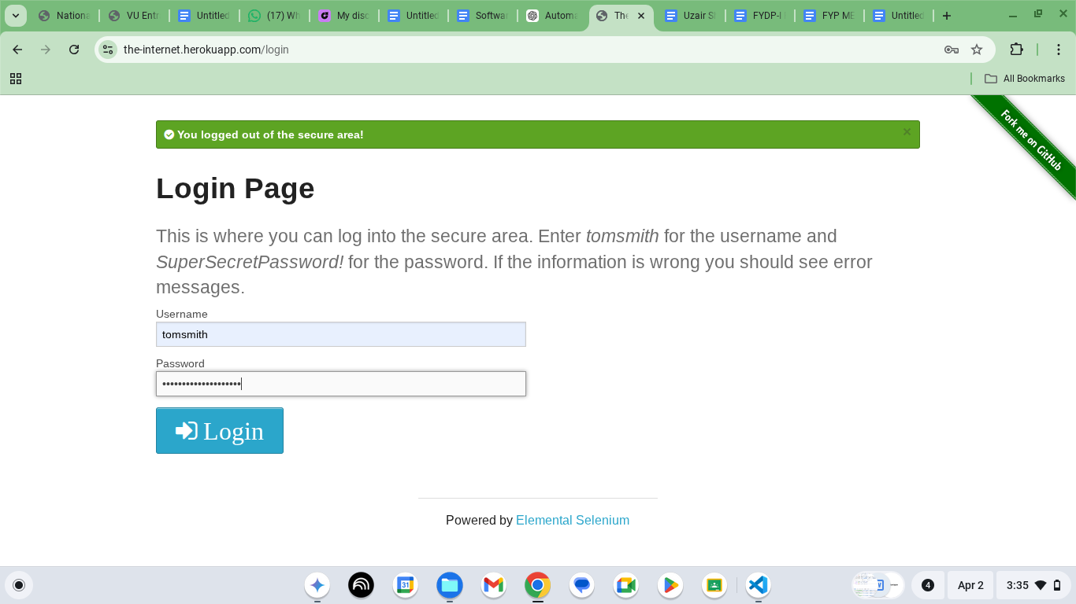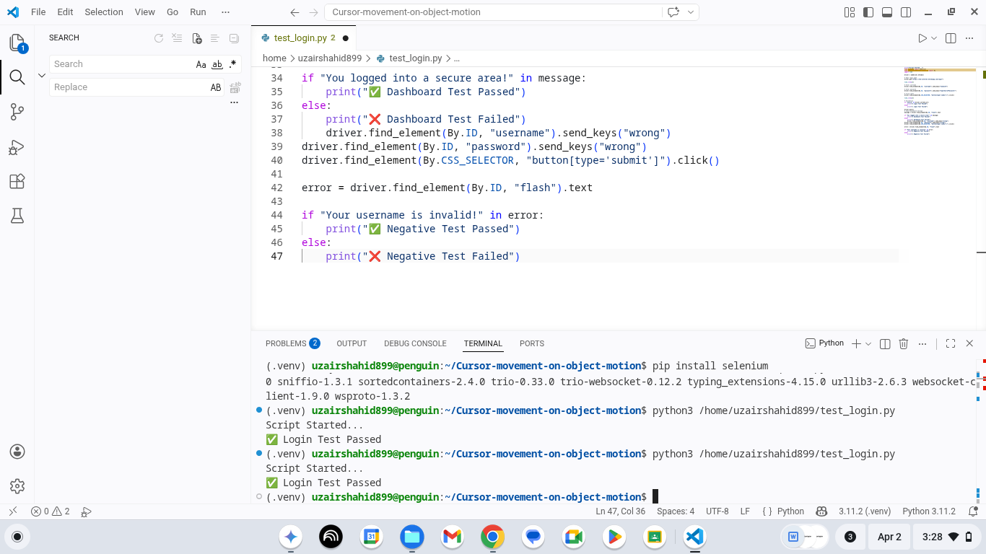

API TESTING REPORT :

Title:
API Testing Report using Postman

Objective:
To test API requests (GET, POST, PUT, DELETE) and verify responses.

Tool Used
- Postman

Base URL
https://jsonplaceholder.typicode.com
Test Cases:

Test Case 1: GET Request
- Method: GET
- Endpoint: /posts
- Full URL:
https://jsonplaceholder.typicode.com/posts

- Steps:
  - Select GET
  - Enter URL
  - Click Send
- Expected Result:
Status code 200 and list of posts
- Actual Result:
Status code 200 and data received
- Status: Passed
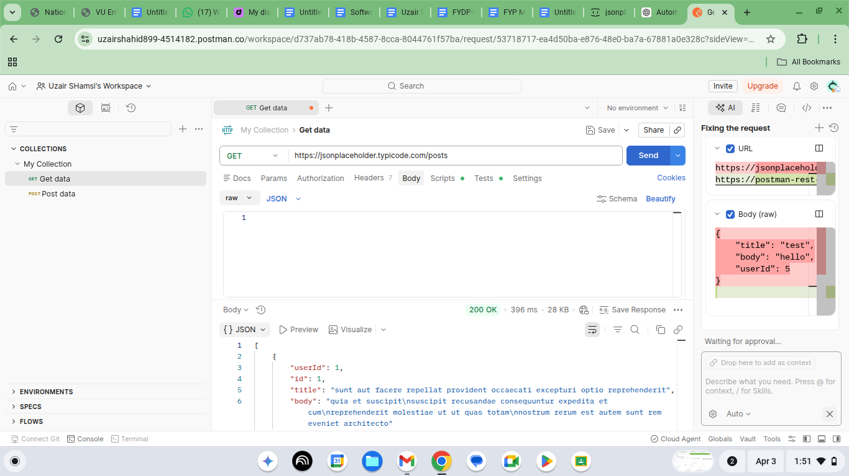

Test Case 2: POST Request
- Method: POST
- Endpoint: /posts
- Body:
{
"title": "test",
"body": "learning API",
"userId": 1
}

- Steps:
  - Select POST
  - Enter data
  - Click Send
- Expected Result:
Status code 201 and new record created
- Actual Result:
Status code 201 and data returned
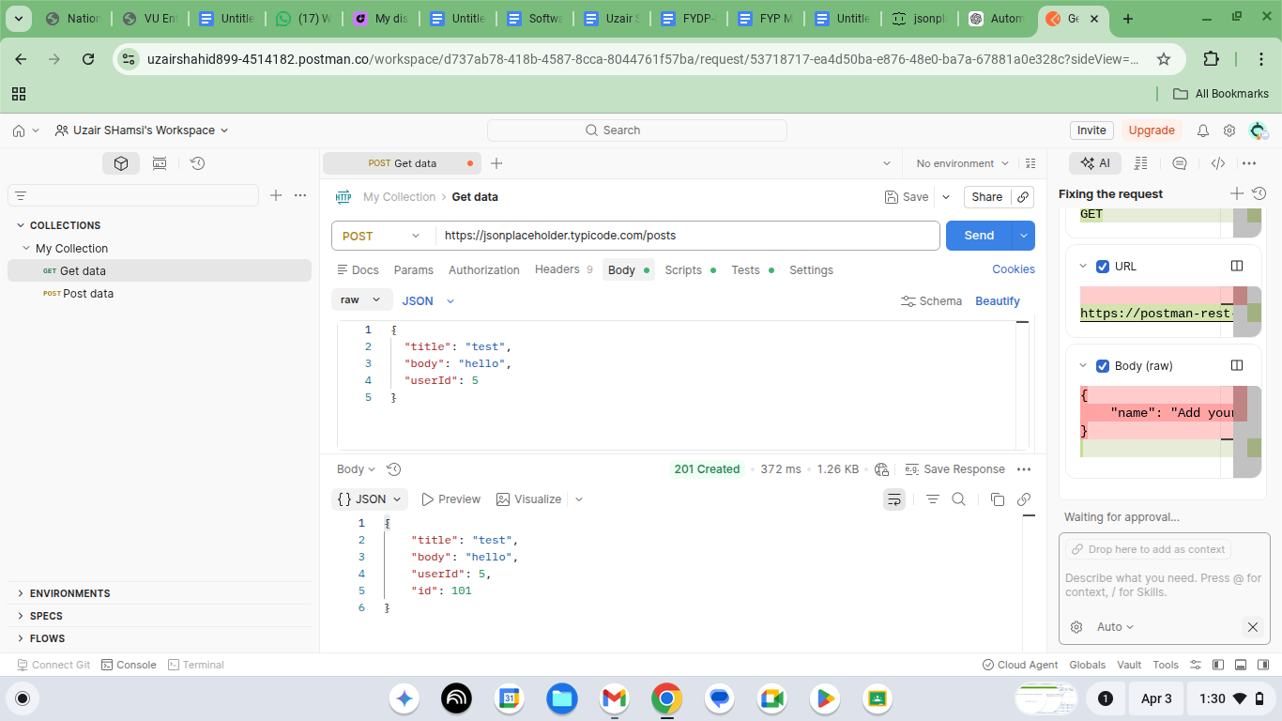
- Status: Passed

Test Case 3: PUT Request
- Method: PUT
- Endpoint: /posts/1
- Body:
{
"id": 1,
"title": "updated",
"body": "updated data",
"userId": 1
}

- Steps:
  - Select PUT
  - Add body data
  - Click Send
- Expected Result:
Status code 200 and data updated
- Actual Result:
Status code 200 and updated data shown
- Status: Passed
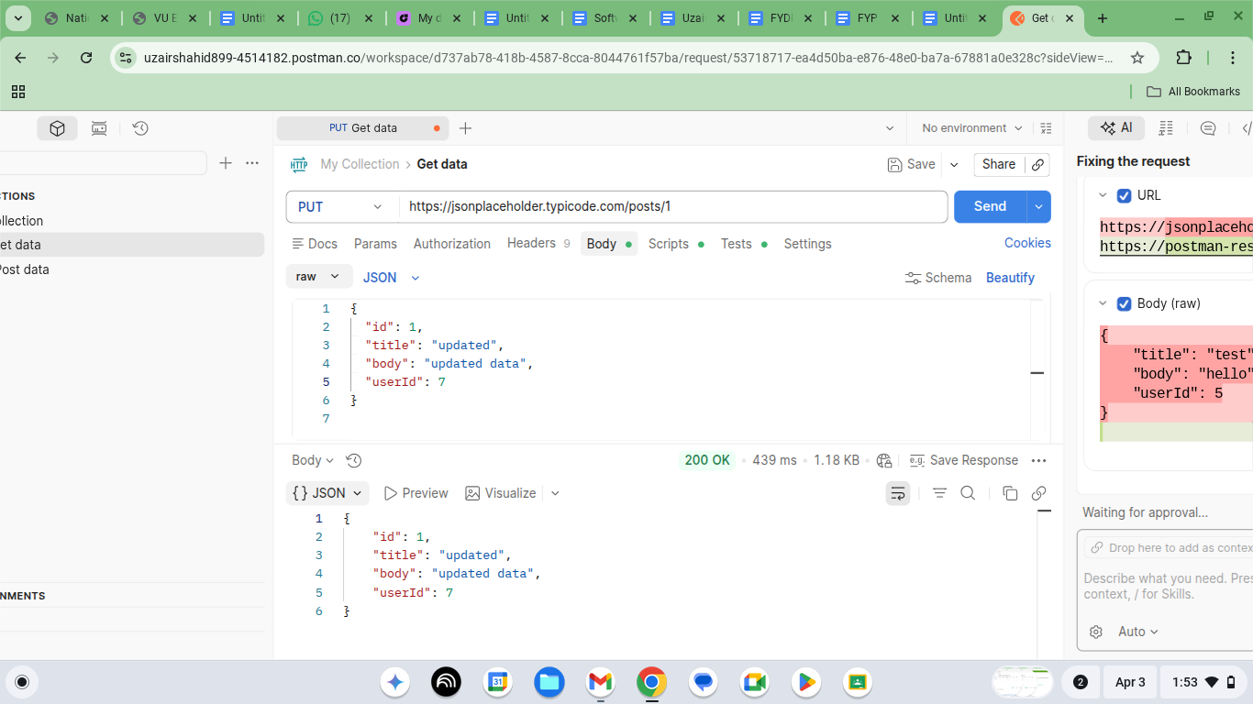

Test Case 4: DELETE Request
- Method: DELETE
- Endpoint: /posts/1
- Steps:
  - Select DELETE
  - Enter URL
  - Click Send
- Expected Result:
Status code 200 and data deleted
- Actual Result:
Status code 200 and empty response
- Status: Passed

